Alg 4 Name: ____________________________

______________ _____________

WS Assessment

Target 22:

Modeling sinusoidal function

**I can:**

* Model and graph sinusoidal function
* Apply Sine and Cosine function in real life problems

**Unit 8: Trigonometry Function**

* [**HSF.TF.A.2**](http://www.corestandards.org/Math/Content/HSF/TF/A/2/): Explain how the unit circle in the coordinate plane enables the extension of trigonometric functions to all real numbers, interpreted as radian measures of angles traversed counterclockwise around the unit circle.
* [**HSF.TF.B.5**](http://www.corestandards.org/Math/Content/HSF/TF/B/5/): Choose trigonometric functions to model periodic phenomena with specified amplitude, frequency, and midline.*
* [**HSF.IF.C.7.E**](http://www.corestandards.org/Math/Content/HSF/IF/C/7/e/): Graph ~~exponential and logarithmic functions, showing intercepts and end behavior, and~~ trigonometric functions, showing period, midline, and amplitude.

HW# 22 Modeling Sinusoidal Function [www.deltamath.com](http://www.deltamath.com)

1. Go to student.desmos.com class code = Stamp:

2. Application of Sinusoidal function **y = a sin b(x + c) + d or y = a cos b(x + c) + d**

*Amplitude = a = the maximum distance from the rest position that the object moves.*

*Period = T = the time it takes the object to complete 1 cycle, a graphical period.*

*Phase Shift = c = the time difference from t = 0 to the start of the 1st cycle.*

*Vertical Shift = d = The distance from the rest position to the reference point, i.e. ground level.*

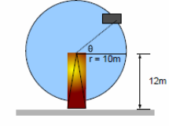The Ferris Wheel has a radius of 10m and is revolving 6 times every minute (this is called the wheel's frequency-also related to radio waves). Assume that the time starts when the Car is on the ground. The wheel's center is 12m from the ground so that there is room for passengers to enter the car.

Sketch the position of the car in with the interval time every 2.5 sec.

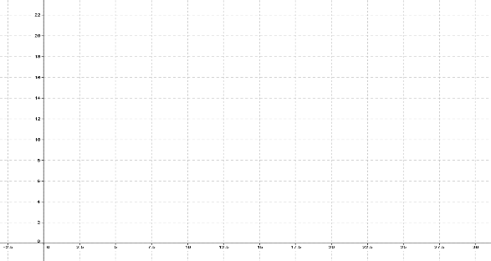Write the sine function that model your sketch then graph them on your calculator. If you can produce the graph that is same as above, call me for stamp:

y = ___________

A long pendulum hangs from the ceiling. As it swings back and forth, its distance from the wall varies sinusoidally with time. At time x = 1 s it is at its closest point, y = 50 cm. Three seconds later it is at its farthest point, y = 160 cm. Sketch the graph of at least 2 periods, then write the sinusoidal function that produce the graph that look like your sketch (your choice of sine or cosine). Show me your calculator for stamp.

*Man on a Waterwheel Problem* Perhaps you have seen the Tom Cruise movie, The Last Samurai. In one scene, a man is tied to a water wheel. Assume the wheel has a diameter of 10 m and the center of the wheel is 3 m above the water. When you first notice the man on the wheel (which moves counterclockwise), the man is at 3 o'clock. Four seconds later, he is at 12 o'clock. Sketch the graph and find how long does he spend under water with each revolution of the wheel? (Hint: use your calculator to find intersections.) Stamp

Sunspot Problem For several hundred years, astronomers have kept track of the number of solar flares, or "sunspots," which occur on the surface of the sun. The number of sunspots counted in a given year varies periodically from a minimum of about 10 per year to a maximum of about 110 per year. Between the maximums that occurred in the years 1750 and 1948, there were 18 complete cycles.

a. What is the period of the sunspot cycle? Sketch two sunspot cycles, starting in 1948.

b. Write an equation expressing the number of sunspots per year in terms of the year.

c. How many sunspots would you expect this year?

d. What is the first year after 2000 in which the number of sunspots will be about 35?

When will it be a maximum? Stamp

Assessment Target 22

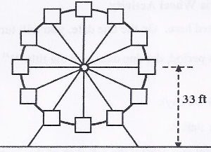**I can…** model and graph sinusoidal function.

A carnival sets up a Ferris wheel in the parking lot of the Flatstown Mall. The diameter of the Ferris wheel is 58 feet. The center of the Ferris wheel is 33 feet above the ground. Twelve seats are evenly spaced around the circumference. The Ferris wheel makes one complete rotation, counterclockwise every 60 seconds.

If your ride last for 3 minutes, sketch a graph that records your distance to from the ground every 5 seconds for the duration of the ride. Write a sinusoidal function that model your sketch. **Stamp**

How high off the ground are you 2.4 minutes into the ride?

For your ride that last for 3 minutes, sketch a graph that records your distance to the left or right as measured from the center of the Ferris wheel every 5 seconds for the duration of the ride. Distance left of the center should be shown as negative. Write a sinusoidal function that model your sketch. Stamp

How far are you to the left or to the right 1.2 seconds into the ride?